|  |  |
| --- | --- |
| Course Name | ITD 2313 – Script Programming |
| Instructor | Mark L. Pranger |
| Student Name | Thomas Webb |
| Due date | 6/3/2025 |
| Grade | Put grade earned here |
| Grading Comments | Put instructor comments here |

**Page 64**

The Code

**Page 65**

**Page 67**

**Page 68**

**Example 1**



**Example 2**

**Page 69**

**Example 1**

**Page 70**

**Example 1**

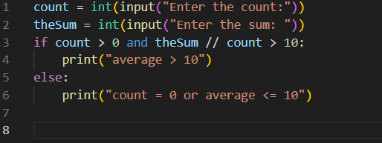

**Page 73**

**Example 1**

**Example 2 (Page 74)**

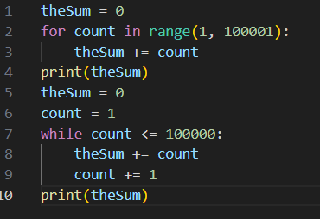



**Example 3 (Page 74)**

**Page 74**

**Example one**

**Example two**

**Page 75   
  
Example one**



**Example 2**

